**Capabilities covered:**

* Use Java to implement business layer of your application
* Use Spring MVC framework to implement presentation layer of an application
* Use Hibernate framework to implement persistence layer of an application
* Use Eclipse IDE for programming Java application
* Test, and Debug your application to make application ready for deployment
* Analyze complex business scenarios and create a data model
* Use MySQL to build SQL engine for an application

**Problem statement:**

Design a web application for an organization, which would like to automate process of assigning project to its employees:

Here is the business scenario:

**Login Page**:

Allow the user to enter the credentials. Below is the sample login page:

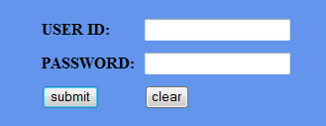

When the form has been submitted it should verify both user id and password from database. If it is valid then displays the Home page, otherwise display the error page.

Below is the sample error page:  
 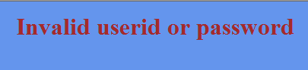

**Home Page:**

This application has two types of user: 1. Admin and 2. User

* For Admin , provide the following links
  + Add User
  + Add Projects
  + View All Projects
  + View All Users
  + View By Emp Id
* For User, provide the following links
  + Change Password
  + View All Projects
  + View Team members

Below is the sample admin & user page:

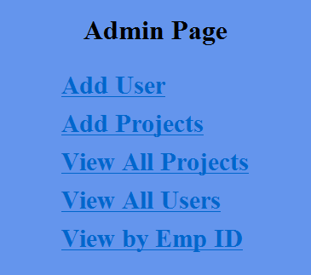

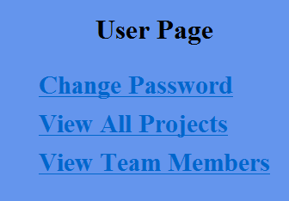

**Add User**

It is an authenticated page.

The page allows the user to enter the user details such as user Id, user name, password, DOJ, email ID, role and project id. When form submission is made then details must be stored in the database.

**Add Project**

It is an authenticated page.

The page allows the user to enter the project details such as project Id, project name, project descriptions and estimated hrs. When form submission is made then details must be stored in the database.

**View All Projects**

It is an authenticated page.

The page displays all the projects which are available in the database.

**View All Users**

It is an authenticated page.

The page displays all the users using html table.

Each row must have user id, user name, DOJ and email. Also display the project link.

When a click is made on the link, display the projects associated to that employee ID

**View By EMP ID**

It is an authenticated page.

This page allows user to enter employee Id and when the form is submitted, it should display employee and his associated project details.

**Change Password**

It is an authenticated page.

The page allows changing password of the user.

**View Projects**

It is an authenticated page.

The page displays the project that is associated to him/her.

**View Team members**

It is an authenticated page

The page displays all the users in the html table format, who are belong to same set of project IDs.

Each row must have user id, user name, DOJ, email and project link.

**Technical constraints:**

1. Use business and DAO layer
2. Display user name and role in all authenticated pages
3. Destroy the session when users logout
4. Handle exceptions and error pages
5. Handle interface in layer interactions
6. Use proper collections
7. Use MVC architecture
8. Design necessary table for EMP details and project details